**Classroom Activity​: Write a function called create FullName that takes a first name and a last name as parameters and returns the full name in the format "First Last"​**

**​Code-**

function createFullName(firstName, lastName) {

return `${firstName} ${lastName}`;

}

// Example usage:

const firstName = "John";

const lastName = "Doe";

const fullName = createFullName(firstName, lastName);

console.log("Full Name: " + fullName);

**Output-**

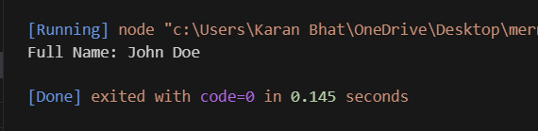

**Execution-Steps:**

* Create a JavaScript file with any name
* Write the code
* And run the code in the terminal using F5 or right click and go to inspect and you can get the output in the console as well.